Project Design Phase-II

Data Flow Diagram & User Stories

|  |  |
| --- | --- |
| Date | 17 May 2023 |
| Team ID | NM2023TMID11884 |
| Project Name | Al enabled car parking using OpenCV |

# Data Flow Diagrams:

A Data Flow Diagram (DFD) is a traditional visual representation of the information flows within a system. A neat and clear DFD can depict the right amount of the system requirement graphically. It shows how data enters and leaves the system, what changes the information, and where data is stored.

# Data Flow Diagram:

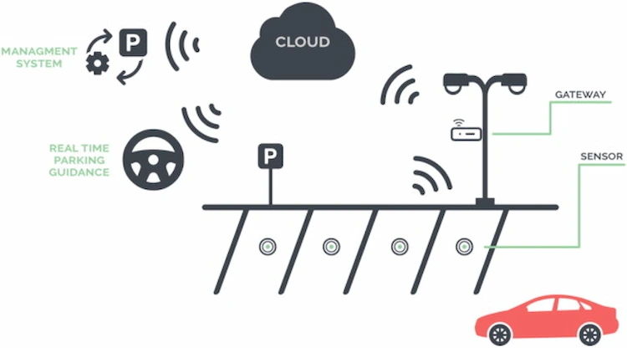

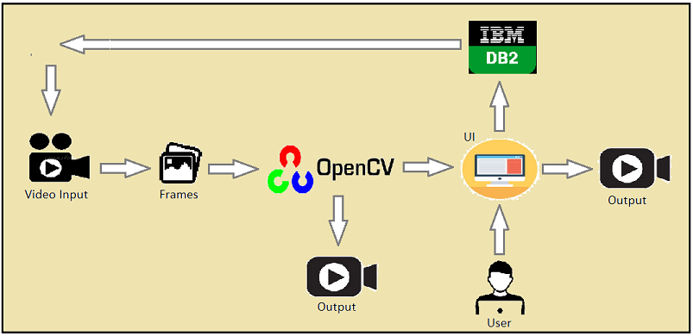

**User Stories**

Use the below template to list all the user stories for the product.

|  |  |  |  |  |  |  |
| --- | --- | --- | --- | --- | --- | --- |
| **User Type** | **Functional Requirement (Epic)** | **User Story Number** | **User Story / Task** | **Acceptance criteria** | **Priority** | **Team Member** |
| Customer | Checking | USN-1 | As a driver, I want to be able to locate an | The AL-enabled car | High | Kumar |
| (Mobile user) |  |  | available parking spot quickly and easily using | parking system using |  |  |
|  |  |  | the car's built-in camera and OpenCV | OpenCV should accurately |  |  |
|  |  |  | technology. | detect the presence of a |  |  |
|  |  |  |  | vehicle within the parking |  |  |
|  |  |  |  | lot and allocate the |  |  |
|  |  |  |  | nearest available parking |  |  |
|  |  |  |  | spot to the vehicle. |  |  |
|  | Checking | USN-2 | As a parking lot operator, I want to be able to | The system should be | High |  |
|  |  | monitor the occupancy of my lot in real-time | able to handle a high |  |  |
|  |  | using OpenCV technology. | volume of vehicles |  | prabhakaran |
|  |  |  | entering and exiting the |  |  |
|  |  |  | parking lot and allocate |  |  |
|  |  |  | parking spots in real-time |  |  |
|  |  |  | without any significant |  |  |
|  |  |  | delays or errors. |  |  |
|  | Checking | USN-3 | As a security officer, I want to be able to identify any suspicious activity in the parking lot using OpenCV technology. | I can register & access the dashboard | Low | Santhosh |
|  | Checking | USN-4 | As a user, I can register for the application through Gmail |  | Medium | dhavamani |
|  | Checking | USN-5 | As a manager, I want to be able to generate reports on parking lot usage, occupancy rates, and revenue using data collected by OpenCV technology. |  | High | Pragadheeshwaran,  kalaiselvan |
|  |  |  |  |  |  | K |
| Customer (Web user) |  |  | As a security officer, I want to be able to identify any suspicious activity in the parking lot using OpenCV technology. |  |  |  |